Nonagonal Prism
# Source: AI Source: Provided by: [Data Path: Persons Table -> ID Column: 1, Name_En Column: Motasem Essam] -> From: [ChatGPT] on [7/25/2026]
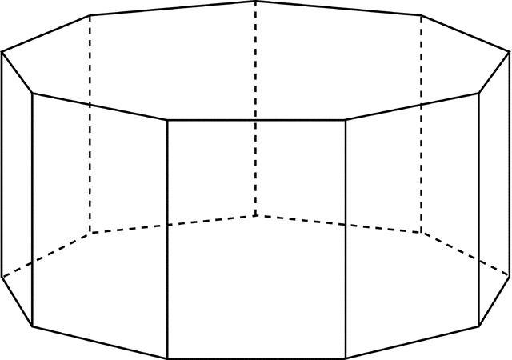

Definition
# Source: AI Source: Provided by: [Data Path: Persons Table -> ID Column: 1, Name_En Column: Motasem Essam] -> From: [ChatGPT] on [7/25/2026]
A nonagonal prism is a three-dimensional polyhedron with two congruent, parallel nonagonal bases connected by nine lateral faces.
Each nonagonal base has nine sides and nine vertices. The nine lateral faces connect corresponding edges of the two bases, forming a closed solid.
A right nonagonal prism has lateral edges perpendicular to the bases and rectangular lateral faces. An oblique nonagonal prism has inclined lateral edges and parallelogram lateral faces.

Simple Definition
# Source: AI Source: Provided by: [Data Path: Persons Table -> ID Column: 1, Name_En Column: Motasem Essam] -> From: [ChatGPT] on [7/25/2026]
A nonagonal prism is a solid shape with two identical nonagons at opposite ends and nine side faces.

Classification Tree
# Source: AI Source: Provided by: [Data Path: Persons Table -> ID Column: 1, Name_En Column: Motasem Essam] -> From: [ChatGPT] on [7/25/2026]
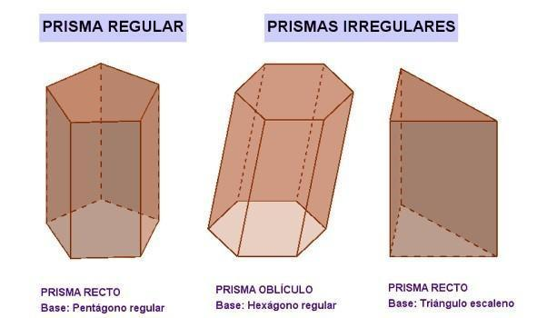
Right Nonagonal Prism
Lateral edges are perpendicular to the bases.
Oblique Nonagonal Prism
Lateral edges are inclined to the bases.
Regular-Base Prism
The bases are regular nonagons.
Irregular-Base Prism
The bases are irregular nonagons.
These classifications describe different properties. For example, a prism can be both right and regular-base. A regular nonagonal prism conventionally has regular nonagonal bases and perpendicular lateral edges.

Key Characteristics
# Source: AI Source: Provided by: [Data Path: Persons Table -> ID Column: 1, Name_En Column: Motasem Essam] -> From: [ChatGPT] on [7/25/2026]
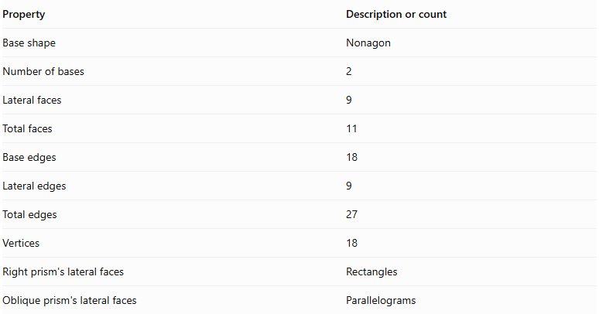
Property | Description or count
Base shape | Nonagon
Number of bases | 2
Lateral faces | 9
Total faces | 11
Base edges | 18
Lateral edges | 9
Total edges | 27
Vertices | 18
Right prism's lateral faces | Rectangles
Oblique prism's lateral faces | Parallelograms

Geometric Representation
# Source: AI Source: Provided by: [Data Path: Persons Table -> ID Column: 1, Name_En Column: Motasem Essam] -> From: [ChatGPT] on [7/25/2026]
The main components of a nonagonal prism are:
- Nonagonal bases: The two congruent, parallel nonagons.
- Lateral faces: The nine faces connecting the bases.
- Base edges: The eighteen edges around the two nonagonal bases.
- Lateral edges: The nine edges joining corresponding vertices of the bases.
- Vertices: The eighteen corner points of the solid.
- Height: The perpendicular distance between the two base planes.
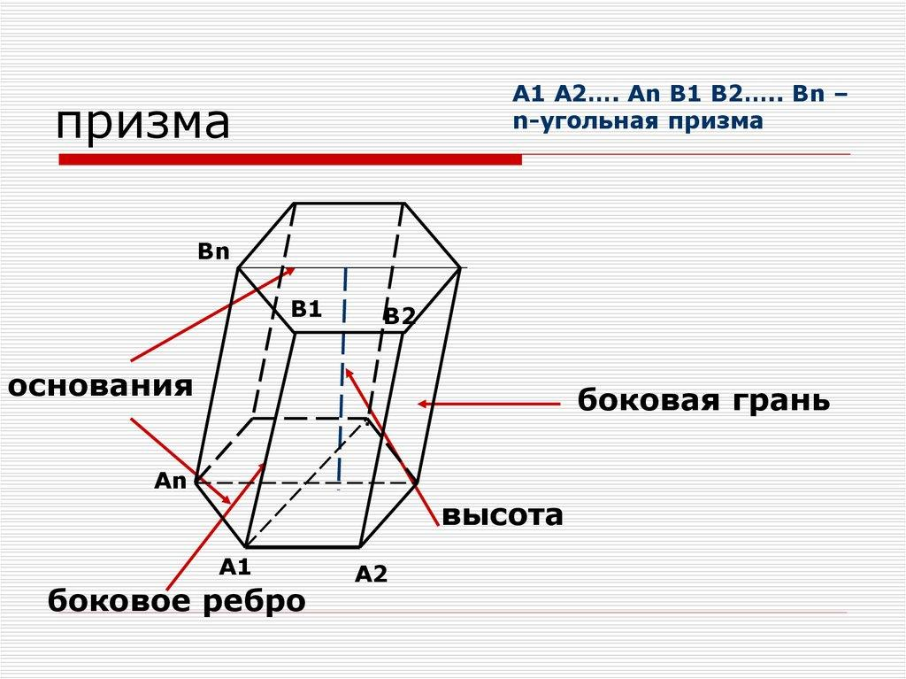

Mathematical Representations and Formulas
# Source: AI Source: Provided by: [Data Path: Persons Table -> ID Column: 1, Name_En Column: Motasem Essam] -> From: [ChatGPT] on [7/25/2026]
Let:
- $B$ = Area of one nonagonal base.
- $P$ = Perimeter of one base.
- $h$ = Perpendicular height of the prism.
- $a$ = Side length of a regular nonagonal base.
- $r$ = Apothem of a regular nonagonal base.

A. Number of Faces, Edges, and Vertices
# Source: AI Source: Provided by: [Data Path: Persons Table -> ID Column: 1, Name_En Column: Motasem Essam] -> From: [ChatGPT] on [7/25/2026]
For a prism with an $n$-sided polygon as its base:
$$F=n+2$$
$$E=3n$$
$$V=2n$$
For a nonagonal prism, $n=9$:
$$F=9+2=\boxed{11}$$
$$E=3(9)=\boxed{27}$$
$$V=2(9)=\boxed{18}$$

B. Area of a Regular Nonagonal Base
# Source: AI Source: Provided by: [Data Path: Persons Table -> ID Column: 1, Name_En Column: Motasem Essam] -> From: [ChatGPT] on [7/25/2026]
For a regular nonagon with side length $a$:
$$\boxed{B=\frac{9a^{2}}{4tan(π/9)}}$$
Its perimeter is:
$$\boxed{P=9a}$$
Alternatively, using the apothem:
$$\boxed{B=\frac{1}{2}Pr}$$
For a regular nonagon, the apothem is:
$$\boxed{r=\frac{a}{2tan(π/9)}}$$

C. Volume
# Source: AI Source: Provided by: [Data Path: Persons Table -> ID Column: 1, Name_En Column: Motasem Essam] -> From: [ChatGPT] on [7/25/2026]
The volume of any prism is its base area multiplied by its perpendicular height:
$$\boxed{V=Bh}$$
For a regular nonagonal prism:
$$\boxed{V=\frac{9a^{2}h}{4tan(π/9)}}$$

D. Lateral Surface Area
# Source: AI Source: Provided by: [Data Path: Persons Table -> ID Column: 1, Name_En Column: Motasem Essam] -> From: [ChatGPT] on [7/25/2026]
For a right nonagonal prism:
$$\boxed{LSA=Ph}$$
Since for a regular nonagon:
$$\boxed{LSA=9ah}$$
For an oblique prism, add the actual areas of its nine lateral parallelograms.

E. Total Surface Area
# Source: AI Source: Provided by: [Data Path: Persons Table -> ID Column: 1, Name_En Column: Motasem Essam] -> From: [ChatGPT] on [7/25/2026]
The total surface area includes the nine lateral faces and both bases:
$$\boxed{TSA=LSA+2B}$$
For a regular right nonagonal prism:
$$\boxed{TSA=9ah+\frac{9a^{2}}{2tan(π/9)}}$$

Worked Examples

Example 1: Counting Faces, Edges, and Vertices
# Source: AI Source: Provided by: [Data Path: Persons Table -> ID Column: 1, Name_En Column: Motasem Essam] -> From: [ChatGPT] on [7/25/2026]
Problem: Find the number of faces, edges, and vertices of a nonagonal prism.
Solution:
The base is a nonagon, so $n=9$.
$$F=9+2=11$$
$$E=3(9)=27$$
$$V=2(9)=18$$
Answer: The prism has 11 faces, 27 edges, and 18 vertices.

Example 2: Calculating the Volume
# Source: AI Source: Provided by: [Data Path: Persons Table -> ID Column: 1, Name_En Column: Motasem Essam] -> From: [ChatGPT] on [7/25/2026]
Problem: A nonagonal prism has a base area of $200{ cm}^{2}$ and a perpendicular height of $15 cm$. Find its volume.
Solution:
$$V=Bh$$
$$V=200×15$$
$$\boxed{V=3000{ cm}^{3}}$$

Example 3: Calculating the Area of a Regular Nonagonal Base
# Source: AI Source: Provided by: [Data Path: Persons Table -> ID Column: 1, Name_En Column: Motasem Essam] -> From: [ChatGPT] on [7/25/2026]
Problem: A regular nonagonal prism has a base side length of $4 cm$. Find the area of one base.
Solution:
Use the regular nonagon area formula:
$$B=\frac{9a^{2}}{4tan(π/9)}$$
Substitute $a=4$:
$$B=\frac{9(4)^{2}}{4tan(π/9)}$$
$$B=\frac{144}{4tan({20}^{∘})}$$
$$\boxed{B≈98.90{ cm}^{2}}$$

Example 4: Calculating Total Surface Area
# Source: AI Source: Provided by: [Data Path: Persons Table -> ID Column: 1, Name_En Column: Motasem Essam] -> From: [ChatGPT] on [7/25/2026]
Problem: A regular right nonagonal prism has a side length of $5 cm$ and a height of $10 cm$. Find its total surface area.
Step 1: Calculate the base perimeter.
$$P=9(5)=45 cm$$
Step 2: Calculate the lateral surface area.
$$LSA=Ph=45(10)=450{ cm}^{2}$$
Step 3: Calculate the area of one base.
$$B=\frac{9(5)^{2}}{4tan({20}^{∘})}$$
$$B≈154.53{ cm}^{2}$$
Step 4: Calculate the total surface area.
$$TSA=LSA+2B$$
$$TSA=450+2(154.53)$$
$$\boxed{TSA≈759.06{ cm}^{2}}$$

Example 5: Verifying Euler's Formula
# Source: AI Source: Provided by: [Data Path: Persons Table -> ID Column: 1, Name_En Column: Motasem Essam] -> From: [ChatGPT] on [7/25/2026]
Euler's formula for a convex polyhedron is:
$$V-E+F=2$$
For a nonagonal prism:
$$18-27+11=2$$
Therefore, the nonagonal prism satisfies Euler's formula.

Comparison with Related Prisms
# Source: AI Source: Provided by: [Data Path: Persons Table -> ID Column: 1, Name_En Column: Motasem Essam] -> From: [ChatGPT] on [7/25/2026]
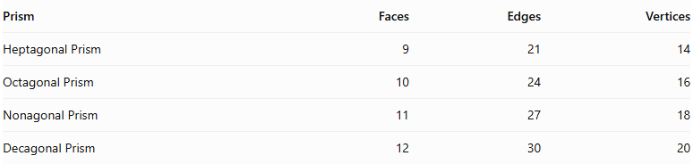
Prism | Faces | Edges | Vertices
Heptagonal Prism | 9 | 21 | 14
Octagonal Prism | 10 | 24 | 16
Nonagonal Prism | 11 | 27 | 18
Decagonal Prism | 12 | 30 | 20
As the number of sides of the polygonal base increases by one, the prism gains one lateral face, three edges, and two vertices.

Constructing Nonagonal Prism in Solid Geometry

Instruments Used
# Source: AI Source: Provided by: [Data Path: Persons Table -> ID Column: 1, Name_En Column: Motasem Essam] -> From: [ChatGPT] on [7/25/2026]
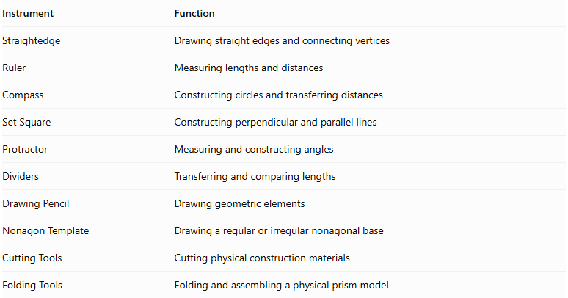
Instrument | Function
Straightedge | Drawing straight edges and connecting vertices
Ruler | Measuring lengths and distances
Compass | Constructing circles and transferring distances
Set Square | Constructing perpendicular and parallel lines
Protractor | Measuring and constructing angles
Dividers | Transferring and comparing lengths
Drawing Pencil | Drawing geometric elements
Nonagon Template | Drawing a regular or irregular nonagonal base
Cutting Tools | Cutting physical construction materials
Folding Tools | Folding and assembling a physical prism model

Construction Procedures

Right Nonagonal Prism Construction
# Source: AI Source: Provided by: [Data Path: Persons Table -> ID Column: 1, Name_En Column: Motasem Essam] -> From: [ChatGPT] on [7/25/2026]
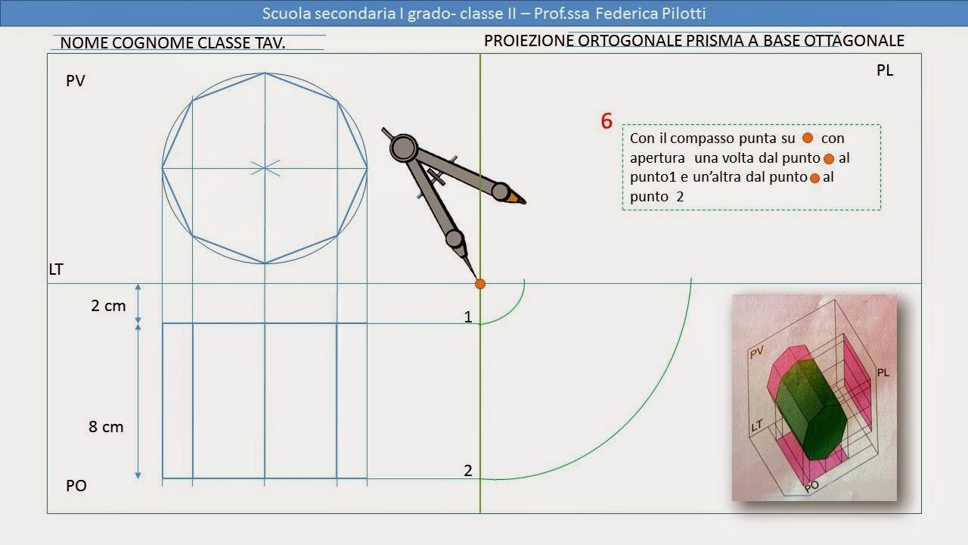
- Construct a nonagonal base using geometric instruments.
- Determine the required perpendicular height.
- Construct a second nonagon congruent to the first.
- Position the second base parallel to the first.
- Ensure that corresponding vertices are aligned along perpendicular lateral edges.
- Connect the corresponding vertices of both bases.
- Complete the nine rectangular lateral faces.
- Identify the visible and hidden edges to complete the geometric representation.

Oblique Nonagonal Prism Construction
# Source: AI Source: Provided by: [Data Path: Persons Table -> ID Column: 1, Name_En Column: Motasem Essam] -> From: [ChatGPT] on [7/25/2026]
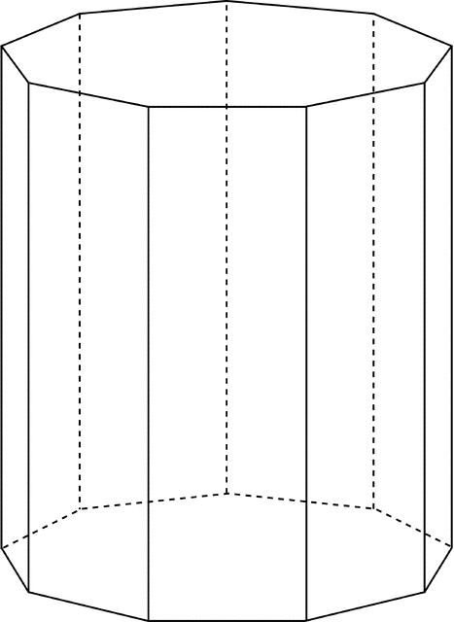
- Construct the first nonagonal base.
- Determine the required direction and inclination of the lateral edges.
- Construct a second nonagon congruent to the first in a parallel plane.
- Displace the second base in the selected oblique direction.
- Connect corresponding vertices using parallel lateral edges of equal length.
- Complete the nine parallelogram lateral faces.
- Identify the visible and hidden edges.

Net-Based Construction
# Source: AI Source: Provided by: [Data Path: Persons Table -> ID Column: 1, Name_En Column: Motasem Essam] -> From: [ChatGPT] on [7/25/2026]
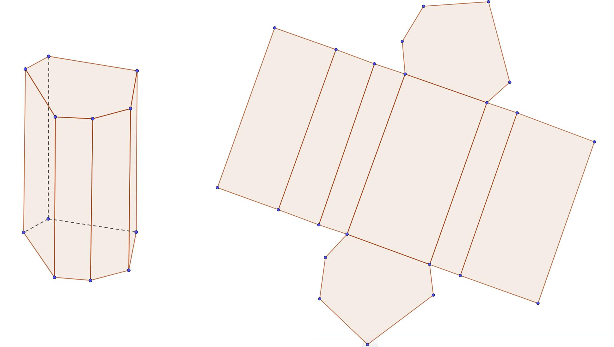
- Construct two congruent nonagonal bases.
- Draw nine connected lateral faces.
- Arrange the lateral faces in a strip.
- Add the two nonagonal bases in suitable positions.
- Add joining tabs if required for physical assembly.
- Cut out the net.
- Fold the lateral faces and attach the two bases.

Extrusion-Based Construction
# Source: AI Source: Provided by: [Data Path: Persons Table -> ID Column: 1, Name_En Column: Motasem Essam] -> From: [ChatGPT] on [7/25/2026]
- Construct a nonagonal base.
- Establish a straight translation direction.
- Transfer the nonagonal boundary along that direction.
- Construct the translated congruent nonagon.
- Connect corresponding vertices.
- Complete the lateral faces to form the prism.

Applications of Nonagonal Prisms
# Source: AI Source: Provided by: [Data Path: Persons Table -> ID Column: 1, Name_En Column: Motasem Essam] -> From: [ChatGPT] on [7/25/2026]
Nonagonal prisms can appear in several practical and mathematical settings:
- Architecture: Nine-sided columns and structural components.
- Engineering: Nine-sided structural components and geometric models.
- Product Design: Objects with nonagonal cross-sections.
- Education: Demonstrating faces, edges, vertices, surface area, and volume.
- Computer Graphics: Representing three-dimensional polygonal objects.

Key Points
# Source: AI Source: Provided by: [Data Path: Persons Table -> ID Column: 1, Name_En Column: Motasem Essam] -> From: [ChatGPT] on [7/25/2026]
- A nonagonal prism has two congruent, parallel nonagonal bases.
- It has nine lateral faces and eleven faces in total.
- It has 27 edges and 18 vertices.
- Its volume is $V=Bh$.
- For a right prism, its lateral surface area is $LSA=Ph$.
- Its total surface area is $TSA=LSA+2B$.
- The area of a regular nonagonal base is $B=\frac{9a^{2}}{4tan(π/9)}$.
- It satisfies Euler's formula $V-E+F=2$.

Conclusion
# Source: AI Source: Provided by: [Data Path: Persons Table -> ID Column: 1, Name_En Column: Motasem Essam] -> From: [ChatGPT] on [7/25/2026]
A nonagonal prism is a polyhedron with two congruent, parallel nonagonal bases joined by nine lateral faces. It has eleven faces, twenty-seven edges, and eighteen vertices, making it a useful example of a prism with a nine-sided polygonal base.
Its volume is calculated by multiplying the base area by the perpendicular height, while its total surface area is the sum of the lateral surface area and the areas of both bases. For a regular nonagonal prism, the base area can be calculated directly from its side length using:
$$B=\frac{9a^{2}}{4tan(π/9)}$$
Understanding the nonagonal prism extends the general rules for polygonal prisms and helps explain how the number of sides of a base determines a solid's faces, edges, and vertices.

